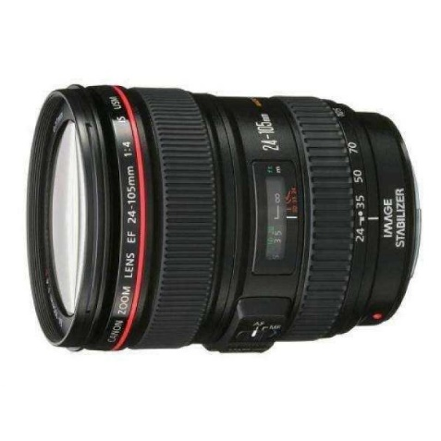



Canon EF 24-105mm F/4L IS USM Lens

₨.78,000

Description:

Canon EF 24-105mm f/4L IS USM Lens Price & Specs
Product Highlights:
- Aperture Range of f/4-22
- EF Mounted L-Series Lens
- One Super-UD & 3elements of aspherical
- Optical Image Stabilization
- Ultrasonic Focus Motor
- Manual Focus Override
- Waterproof and Dustproof Sealing
- Min. Focus Distance of 1.5inches
- Filter Thread has 77mm Diameter
If you could just have 1 lens, many photographers would select the upgraded EF 24-105mm f/4L IS II USM Lens from Canon due to its remarkably adaptable zoom range from large angle to short telephoto, a constant f/4 aperture, and an exceptional build quality be suitable an L-series lens. This version II of the admired lens makes enhancements to image worth through the use of a latest optical design with 4 glass-molded aspherical elements that helps to limit igniting in the images. Also, it uses an Air Sphere Coating to minimize flaring and ghosting.
A ring-type Ultrasonic Motor AF system offers quick and precise autofocus while integrated optical image stabilization can help recompense for about 4 stops of shutter rate, reducing the effects of camera tremble. This lens also provides a zoom lock button to prevent lens steal when not vigorously in use as well as an inner focus system. Full-time manual focus override is available for making modifications regardless of the AF mode. Furthermore, it has a curved 10-blade aperture diaphragm for even out of focus elements.
Like all L-series lenses, it also has number of seals which makes it favorable for water and dust resistant and also helps while working in moist weather. On the exposed rear and front elements it uses fluorine coating which makes it easy for cleaning and prevents smudges.
Providing a flexible zoom range of 24 to 105mm, this Lens of L-series is a staple of many shooters kits. This upgraded version provides better image quality, with a prominent improvement in peripheral brightness.
Structured for utilize with full-frame DSLRs, this optic is well-suited with APS-C format cameras as well where it will give a range of 38.4 to 168mm equivalent focal length
Constant f/4 max. Aperture provides consistent performance and light spread throughout the zoom range.
4 glass-molded aspherical elements, including one huge-diameter dual-sided glass-molded lens, help to reduce distortions all through the zoom range in order to preserve edge-to-edge illumination and sharpness.
An Air Sphere Coating (ASC) has been applied to elements of lens to minimize backlit ghosting and flaring for maintained transmission of light and high contrast in powerful lighting conditions.
A ring-type Ultrasonic Motor (USM), along with an inner focusing system, optimized AF algorithms and high-speed CPU, are employed to deliver quick, complete, and near-silent autofocus performance.
Optical image stabilization reduces the effects of camera tremble by compensating for up to four stops of shutter speed.
Full-time manual focus process is available for fine-tuning of focus position when working in the AF mode.
Zoom lock avoids lens creep when it is not in use.
A weather-resistant structure protects the lens from moisture and dust to allow its use in stormy conditions. Moreover, fluorine coatings also applied to the rear and front lens elements for more protection against fingerprints and blurring.
10 rounded diaphragm blades give to a pleasing out of focus worth that benefits the use of low depth of field and choosy focus techniques.

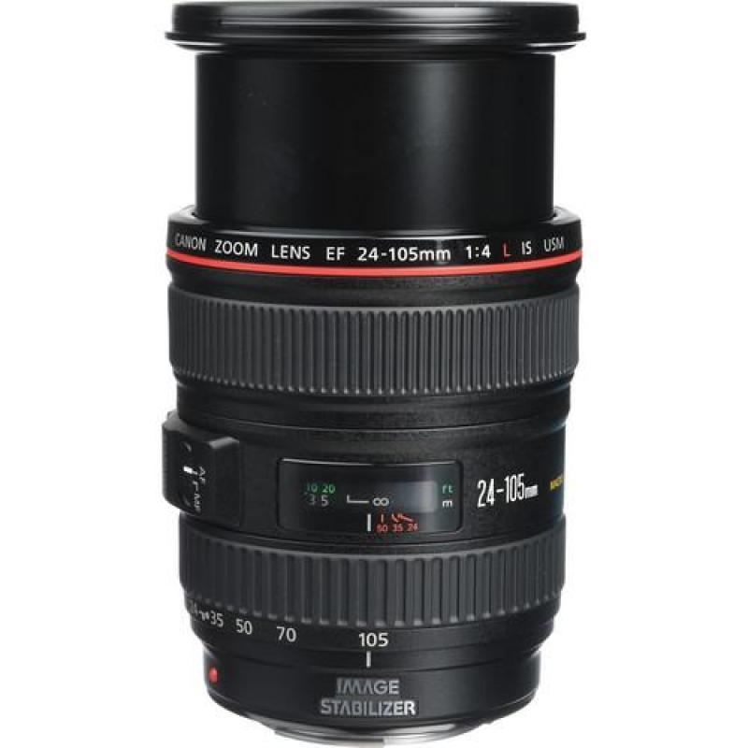
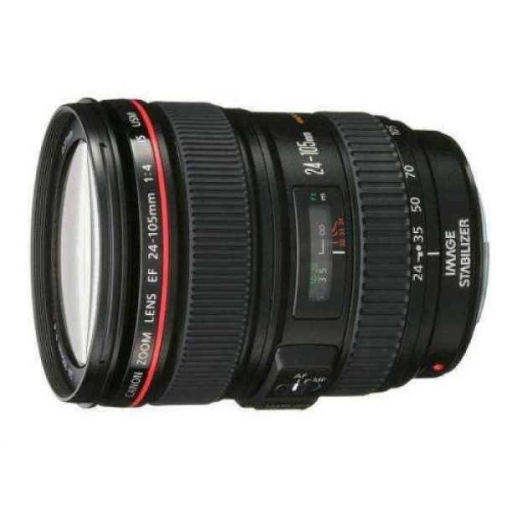
Pictures:

